JIM PREPARATORY NURSERY & PRIMARY SCHOOL
IKI-IKI
MOTTO: OUR GOD IS ABLE
TERM TWO ASSEAAMENT EXAMS SET V 2023
PRIMARY FOUR
MATHEMATICS
DURATION: 2HRS 15 MIN
NAME: ..................................................................................
STREAM: ..............................................................................
INSTRUCTIONS:
- This paper has two Sections: A and B.
- Section A , has 20 questions (40 marks)
- Section B has 12 questions (60 marks).
- Answer ALL questions. All answers to both Sections A and B must be written in spaces provided.

- All answers must be written using a blue or black ballpoint pen or ink but not pencil. All work done in pencil except diagrams will NOT be marked.

- Unnecessary alteration of work will lead to loss of marks.
SECTION | EXAMINER’S MARK | HOD’S MARK
A
B
TOTAL

SECTION A (40 MARKS)

1. Multiply : 3 $×$ 4

2. Change 7 kg to grams .

3. Expand 390 in value form .

4. The cost of 3 pens is sh. 1,500 . Find the cost of one pen .

5. Add 5 $+$ 4 using a number line below.

0 1 2 3 4 5 6 7 8 9 10 11 12 13

6. Work out:
$\frac{6}{10}$ $+$ $\frac{4}{10}$

7. Find the perimeter of a square garden whose sides is 7 metres.

8. Think of a number, subtract 9 from it and the difference is 12 . What is the number ?

9. Divide: 4 5 7 2

10. Find the sum of the first 4 even numbers .

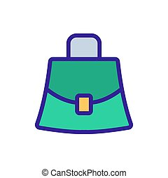
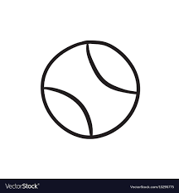
11. If M $=$ ball , bench , bag and N $=$ , ,
Describe the relationship between set M and set N .

12. Show the time on the clock face below .
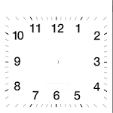
A half past 2 O’clock .

13. Find the number expanded below .
3 hundreds $+$ 7 tens $+$ 5 ones

14. Simplify: 9 cups $+$ 6 cups $-$ 4 cups

15. Write the shaded fraction of the figure below .

16. Shade P$∩$Q on the Venn diagram below .
P Q

17. Find the area of the figure below .

18. How many five hundred shillings coins can be got from 2,000 shillings ?

19. If 60 minutes $=$ 1 hour , how many hours are there in 180 minutes ?


20. Given that stands for 6 books . How many books are represented by ?

SECTION B (60 MARKS)

21. Use the digits 5 , 3 , 9 to answer the questions that follow .

(a) Form the largest 3 – digit number using the digits above .
(1 mark)

(b) Form the smallest 3-digit number using the digits above .
(1 mark)

(c) Find the sum of the smallest and the largest number formed above . (2 marks)

22. Given that H Whole numbers between 10 and 18 .

G Odd numbers between 10 and 20 .

(a) List all the members of ;
(i) set H$=$ (1 mark)

(ii) set G$=$ (1 mark)

(b) Find n(H$-$G) . (2 marks)

23. Three children shared apples such that Agnes got $\frac{2}{5}$ , Bob got $\frac{1}{5}$ and Juma got the rest .

(a) What fraction did Agnes and Bob get ? (2 marks)

(b) What fraction was given to Juma ? (2 marks)

(c) If the total number of apples was 20 , how many apples did Bob get ? (2 marks)

24(a) Work out : Weeks Days (1 mark)

7 3
$+$ 5 2

(b) Given that R$=$ All months of the year with 30 days .
Find the members of set R . (1 mark)

(c) If 1 day $=$ 24 hours , how many hours are in a week ?
(2 marks)

25(a) Annet bought 256 apples and Joan bought 144 apples .
How many apples did they buy altogether ? (2 marks)

(b) The District Education Officer gave 246 textbooks to one school . How many textbooks did she give to 3 schools altogether ? (2 marks)

26(a) List a set of multiples of 5 less than 30 . (1 mark)

(b) Find the next two numbers in the sequence .
0 , 4 , 8 , 12 , 16 , …….. , ……... (2 marks)

(c) Work out the L.C.M of 3 and 4 . (2 marks)

27. Use a number line to work out .

(a) 10 $-$ 6 $=$ (2 marks)

0 1 2 3 4 5 6 7 8 9 10 11 12

(b) 2 $×$ 4 $=$ (2 marks)

0 1 2 3 4 5 6 7 8 9 10 11 12

(c) Work out using repeated addition . (2 marks)

4 $×$ 3

28. Mugenyi weighs 24 kg and Mangeni weighs 8 kg heavier than Mugenyi . (2 marks)

- What is Mangeni’s weight ?

(b) Find their total weight . (2 marks)

(c) Add : kg grams (1 mark)

5 450
$+$ 3 350

29. Below is Rhona’s back-to-school shopping list. Use it to answer the questions that follow .
Item Amount
Sh. 1,000

Sh. 4,500

Sh. 15,000

Sh. 3,000

Sh. 7,000
Ruler

Box file

School bag

Note book

Counter book

(a) Which is the most expensive item ? (1 mark)

(b) Find the cost of a box file and a ruler altogether . (2 marks)

(c) If Rhona had a five thousand shillings note and bought a box file , how much was her balance ? (2 marks)

30(a) Name the following shapes . (1 mark @)
(i) (ii)

…………………… ……………………

(b) Draw the following figures . (2 marks @)
(i) rectangle (ii) cylinder

31(a) Think of a number, multiply it by 5 and the answer is 15 . What is the number ? (2 marks)

(b) Find the value of the unknown . (2 marks @)
(i) $+$ 7 $=$ 20 (ii) $-$ 6 $=$ 13

32. The pictograph below shows the flowers planted in the school compound in different months .

February | 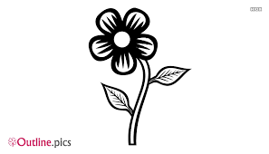
March

April

May

June

Scale: stands for 5 flowers ?

(a) In which month were the most number of flowers planted ?
(1 mark)

(b) How many flowers were planted in March ? (1 mark)

(c) In which two months were the same number of flowers planted ? (1 mark)

(d) Find the total number of flowers planted for all the five months . (2 marks)

END

